Ideation Phase
Empathize & Discover
Date | 28.09.2026
Team ID | SWTID-2026-4440
Project Name | Automated IT Ticket Classification and Notification System
Maximum Marks | 4 Marks
Activity: 1 Business Use Case
Business Requirements
The proposed system is an intelligent IT service-management solution that receives incident tickets, understands the issue description, classifies the ticket automatically, assigns an appropriate Category and dependent Subcategory, notifies the caller, and stores standardized ticket data for service-desk operations and future reporting. The objective is to reduce manual triage, improve routing accuracy, shorten response time, and provide a scalable foundation for IT support.
The system must:
- Automatically classify IT tickets based on the issue description. The system shall analyse the caller's submitted short description and detailed issue description, identify key terms and intent, and recommend or assign the most relevant ticket category.
- Assign both Category and Subcategory without manual intervention. After classification, the system shall populate both fields automatically before the ticket is routed or saved, while allowing authorised users to correct the values when necessary.
- Support dependent choice logic between Category and Subcategory. The available Subcategory values shall depend on the selected Category. For example, a Hardware category may expose Laptop, Desktop, Monitor, or Printer subcategories, while a Software category may expose Application Error, Installation, Access, or Performance subcategories. Invalid Category–Subcategory combinations shall be prevented.
- Send an automated email notification to the caller upon ticket creation. After successful ticket creation, the system shall send a confirmation email containing the ticket number, issue summary, assigned Category, assigned Subcategory, creation date and time, and the next expected support step.
- Store ticket information in a structured and standardized format. Each ticket shall store a unique ticket identifier, caller details, issue description, Category, Subcategory, priority or impact information when available, creation timestamp, notification status, assignment status, and audit information in consistent fields.
- Ensure easy maintenance and future scalability. Classification rules, Category and Subcategory mappings, notification templates, and validation rules shall be configurable and maintainable without major changes to the core application. The design shall support additional categories, new issue types, higher ticket volumes, and integration with future IT service-management modules.
Primary Business Use Case: Create and Classify an IT Ticket
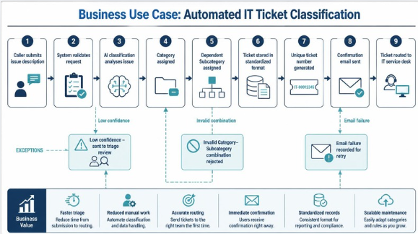

Use Case ID | UC-01
Use Case Name | Create and Automatically Classify an IT Ticket
Primary Actor | Caller / Employee requesting IT support
Supporting Actors | IT service desk, classification service, notification service, ticket database
Trigger | The caller submits a new IT support request with an issue description.
Preconditions | The caller can access the ticket-submission form; required caller and issue fields are available; Category and Subcategory configuration exists; email delivery is configured.
Postconditions | A unique ticket is created and stored; Category and Subcategory are assigned; the ticket is available for service-desk processing; a confirmation email is sent or its delivery status is recorded.
Main Success Flow | 1. The caller opens the IT ticket form.  2. The caller enters the issue description and required details.  3. The system validates the submission.  4. The classification service analyses the issue description.  5. The system assigns a Category.  6. The system filters valid Subcategory choices based on that Category.  7. The system assigns the most relevant Subcategory.  8. The system stores the ticket in the standardized format.  9. The system generates a unique ticket number.  10. The notification service sends a confirmation email to the caller.  11. The system makes the ticket available to the IT service desk.
Alternative Flow A: Low classification confidence | If the system cannot classify the issue with sufficient confidence, it shall assign a configured default Category and Subcategory or place the ticket in a triage queue, mark it for review, store the classification reason, and continue ticket creation without losing the caller's information.
Alternative Flow B: Email delivery failure | If the confirmation email cannot be delivered, the system shall retain the ticket, record the notification failure, show the ticket number to the caller when possible, and make the notification available for retry.
Alternative Flow C: Invalid dependent selection | If a Subcategory does not belong to the selected Category, the system shall reject the combination, clear the invalid value, and require a valid dependent Subcategory.
Exception Flow | If ticket creation fails because of a system or database error, the system shall display a clear error message, avoid creating a duplicate ticket, log the failure, and allow a safe retry.
Business Value | Faster and more consistent triage, reduced manual work, improved routing accuracy, immediate caller confirmation, standardized reporting data, and a maintainable foundation for future automation.
Empathy Map Canvas:
An empathy map captures the behaviours, needs, concerns, and expectations of the people affected by the solution. For this project, the primary perspective is the employee or caller who submits an IT ticket, with service-desk needs included where they directly affect the business use case.
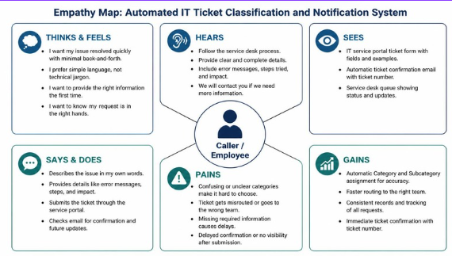

THINKS AND FEELS | The caller wants the issue resolved quickly and does not want to learn complicated IT terminology. The caller may worry that the request will be routed incorrectly, that important details will be missed, or that there will be no confirmation after submission. The service desk wants reliable classification and complete information so tickets can be handled efficiently.
HEARS | The caller hears colleagues advise them to contact the service desk, follow internal support procedures, or include specific technical details. The service desk hears repeated requests for clearer issue descriptions, fewer misrouted tickets, and better categorization for reporting.
SEES | The caller sees a ticket form with fields for the issue description and contact information, followed by a confirmation message or email. The service desk sees a queue containing ticket numbers, caller details, issue descriptions, Categories, Subcategories, priorities, timestamps, and assignment status.
SAYS AND DOES | The caller describes the problem in everyday language, submits the form, checks email for confirmation, and may follow up if the ticket is not acknowledged. The service desk reviews the classification, corrects exceptions when needed, assigns or works the ticket, and uses standardized data to track performance.
PAINS | Manual category selection is confusing; the caller may not know the correct technical classification; tickets may be routed to the wrong team; important information may be inconsistent; confirmation may be delayed or missing; service-desk staff may spend time correcting classifications; reporting may be unreliable.
GAINS | Simple ticket submission; automatic and accurate Category and Subcategory assignment; valid dependent choices; immediate confirmation with a ticket number; faster routing; consistent records; easier reporting; configurable rules; and a scalable platform for future automation.
Functional and Quality Expectations
- Classification accuracy: The system should identify the most appropriate Category and Subcategory from the issue description and record the classification result.
- Consistency: Equivalent issue descriptions should produce consistent classifications when the configuration and model version are unchanged.
- Traceability: The system should retain classification, correction, notification, and audit information.
- Usability: The caller should be able to submit a ticket using clear, understandable fields with minimal effort.
- Maintainability: Administrators should be able to update mappings, rules, templates, and supported values without redesigning the complete system.
- Scalability: The system should support increasing ticket volume, additional categories, more users, and future integrations.
- Reliability: Ticket creation and storage must avoid data loss and duplicate records during retries or temporary failures.
- Security and privacy: Caller and ticket information should be protected through appropriate access control, secure transmission, and audit logging.
Acceptance Criteria
- Given a valid issue description, when the caller submits a ticket, then the system creates a unique ticket and automatically assigns a Category.
- Given an assigned Category, when the system evaluates Subcategory values, then only valid dependent Subcategories are available and one appropriate Subcategory is assigned.
- Given a successfully created ticket, when notification processing runs, then the caller receives an email containing the ticket number and relevant ticket details, or the system records a retryable delivery failure.
- Given a created ticket, when an authorised user reviews it, then the caller information, issue description, Category, Subcategory, timestamps, and status are stored in standardized fields.
- Given a new classification rule or mapping, when an administrator updates the configuration, then the change can be maintained without rewriting the core ticket-submission workflow.
- Given a classification failure or temporary service error, when the ticket is submitted, then the system preserves the request, avoids duplicate creation, records the failure, and supports safe review or retry.
References:
Source template: Uploaded PDF, Ideation Phase – Empathize & Discover

